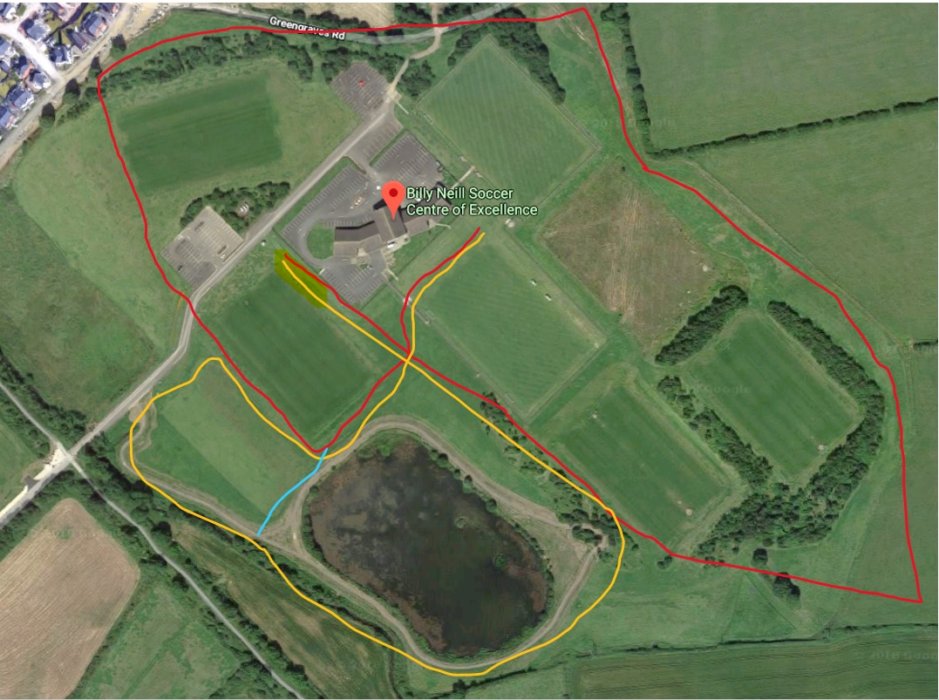

Finish

Start

**U13 (Girls & Boys)** – 2000m – 1 Red Lap

**U15 (Girls & Boys)** – 3000m – 1 Yellow Lap + 1 Red Lap

**Open Mixed Race** – 4000m – 2 Red Laps

**U17 & U20 Girls (Junior Women)** – 4000m – 2 Red Laps

**Flahavan’s Porridge Primary School Girls Race** – 1200m – 1 Yellow Lap + Finish Straight

**U17 & U20 (Junior Men)** – 6000m – 3 Red Laps

**Flahavan’s Porridge Primary School Boys Race** – 1200m – 1 Yellow Lap + Finish Straight

**Senior International Women** – 8000m – 4 Red Laps

**Senior International Men** – 10,000m – 5 Red Laps

**Red Lap = 2000m**

**Yellow Lap = 1000m** – (Only used for Primary School, and U15 races)

*Distance of lap is Approximate